

Latchkey News & Updates

**Flip me over for more**

**Important information**

All Latchkey families are cordially invited to attend our annual

Parent Open House

February 7, 2019 (4:30 PM to 6:00 PM)

2554 Locust Ave W, Suite A

University Place, WA 98466

(Main Office)

*Come for 10 minutes or an hour. Your choice!*



February is a short month packed with a punch. We are at the ½ way point of the school year and we thank you for your trust in allowing us to provide before and after school childcare for your family.

The University Place School District is closed Friday, February 15th. Latchkey **will operate a combined program at Sunset Primary for all families who have registered for the day.** Access to our program will be through the outside cafeteria/gym doors located on the left and right side as you face the building from the parking lot. With a combined operation, not all of our employees are familiar with you and your emergency contacts. Please be prepared to show photo ID when you pick up your child. On a final note, Latchkey will provide morning and afternoon snacks; however, **your child needs a lunch from home**. Please adhere to our “no peanut/tree nut” policy located in the Parent Handbook when preparing your child’s lunch. Homemade treats in your child’s lunch are always a nice touch. Please be sure all home baked items are peanut/tree nut free. **Our staff checks all lunches for compliance.** Lunches must be “ready to eat”. The children do not have access to hot water, refrigeration or a microwave.

Please remember, **all Latchkey programs will be closed on February 18th in observance of Presidents’ Day.**

Tricia Alsbaugh

*Executive Director*

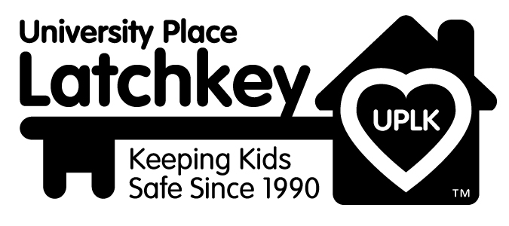

**Lunch from Home on February 15th**

We provide a morning and afternoon snack during winter break; however, you will need to provide a lunch from home for your child. We realize peanuts and tree nuts are a great source of protein for many children. Unfortunately, they are life threatening to several children in our program. Please help us to keep those children safe during our combined days by packing a peanut/tree nut free lunch.

We’ve provided a list of great alternatives to help you in preparing your child’s lunch. Homemade treats in your child lunch are always a nice touch. Please be sure all home baked items are peanut/tree nut free.



**Nut/Tree Nut Alternatives for Lunch**

Lunch meat

Cheese

Yogurt (but watch for nut toppings)

Cottage cheese

Bagel with cream cheese

Nutrigrain bars

Protein Drink-Pedia Sure

WOW Butter!-soy peanut butter

(Usually comes with stickers for your lunch)

Sunflower seed butter

Chef Salad

Hard boiled eggs

Fruit with cheese slices

Thermos of soup w/crackers

Thermos of Pasta Primavera w/chicken

Leftover Pizza

Quiche Tart

Tuna Salad

Chicken Salad

 Hummus and pita bread

